Functional specifications 3D TICKETING SDK PACIFA

2020

|  |  |  |
| --- | --- | --- |
| Diffusion | | |
| *company* | ***who*** | ***role*** |
| PACIFA decision | Bruno MUNZER | CTO |
| Thomas MARQUES |  |
| stadion | Olivier LEGRIS |  |
| PSG | Hugo CHARRIER |  |
|  |  |  |

|  |  |  |  |
| --- | --- | --- | --- |
| Versions | | | |
| Version | Date | Autor | comment |
| 1.0 | 27/03/2020 | Bruno MUNZER | First version |
| 1.1 | **21/04/2020** | **Bruno MUNZER** | **Scope definition** |

Summary

1. Introduction 3

2. Scope of the SDK 3

3. Global Software design 3

4. Multipurpose SDK use 3

5. Scenario of PACIFA SDK use 4

5.1. Get the native SDK component (example of the top view) 4

5.2. Get only data (example of the top view) 4

6. List of components 5

6.1. Top view with the roof 5

6.1.1. Design 5

6.1.2. List of features 5

6.2. Top view without the roof 6

6.2.1. Design 6

6.2.2. List of features 6

6.3. Block view 7

6.3.1. Design 7

6.3.2. List of features 7

6.4. Panoramic view 8

6.4.1. Design 8

6.4.2. List of features 8

# Introduction

This document presents the functional part of the SDK 3D TICKETING PACIFA.

# Scope of the SDK

The scope of the SDK is limited to the presentation of the 3D views provided by PACIFA API. More precisely, the sdk will permit to create dedicated component and display the same content as the API PACIFA.

Availabilities of seats, blocks, categories, events have to be done in the APP by App owner from BACK OFFICE data. SDK PACIFA will permit only to display PACIFA content. The selling process has to be done by the app owner.



# Global Software design



# Multipurpose SDK use

The vision of the SDK is to propose some dedicated component to present all steps of the 3D selling process. It will permit also to get only the needed data to build the forms.

The SDK will permit to

* Create dedicated components with all needed features
* Get only data

# Scenario of PACIFA SDK use

* Red actions are up to the APP
* Blue actions are up to PACIFA SDK

## Get the native SDK component (example of the top view)



## Get only data (example of the top view)



# List of components

## Top view with the roof

### Design

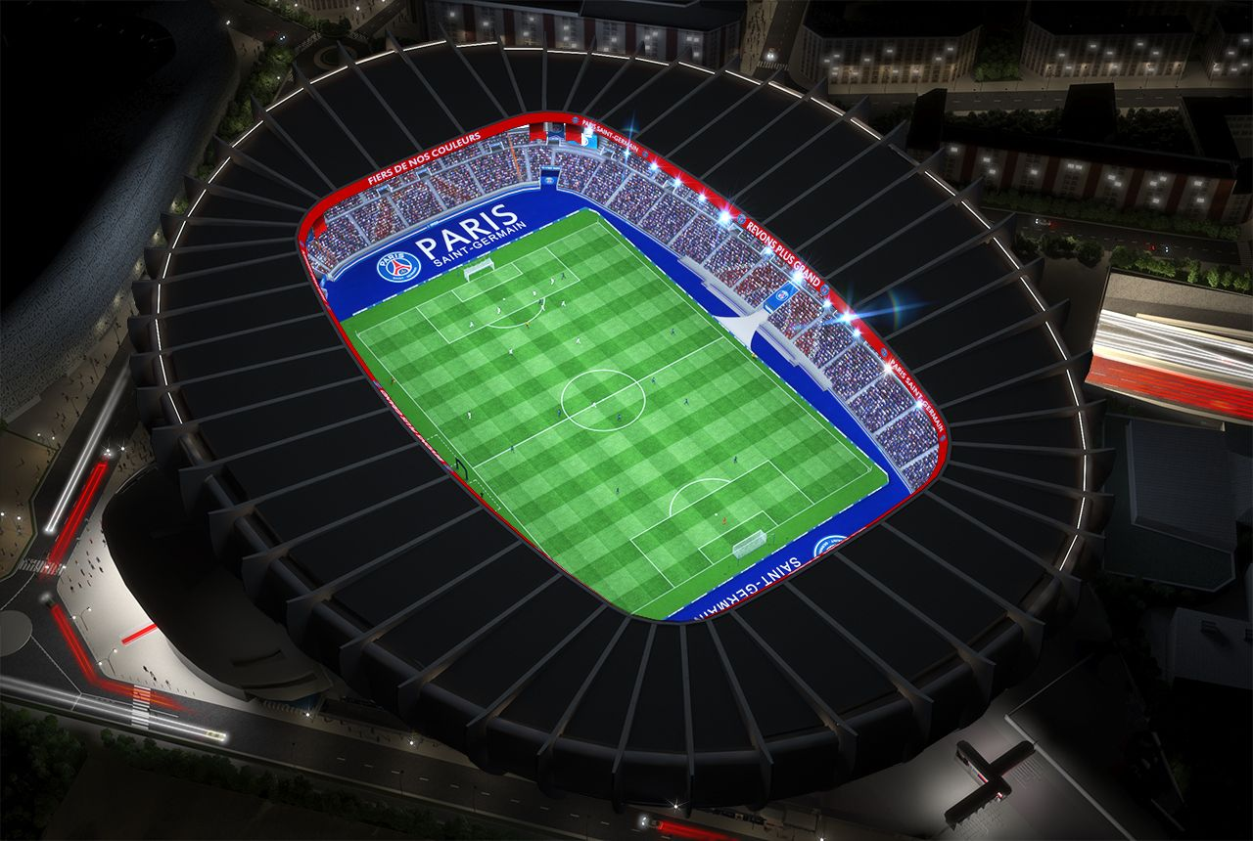

### List of features

* Hide the roof

## Top view without the roof

### Design

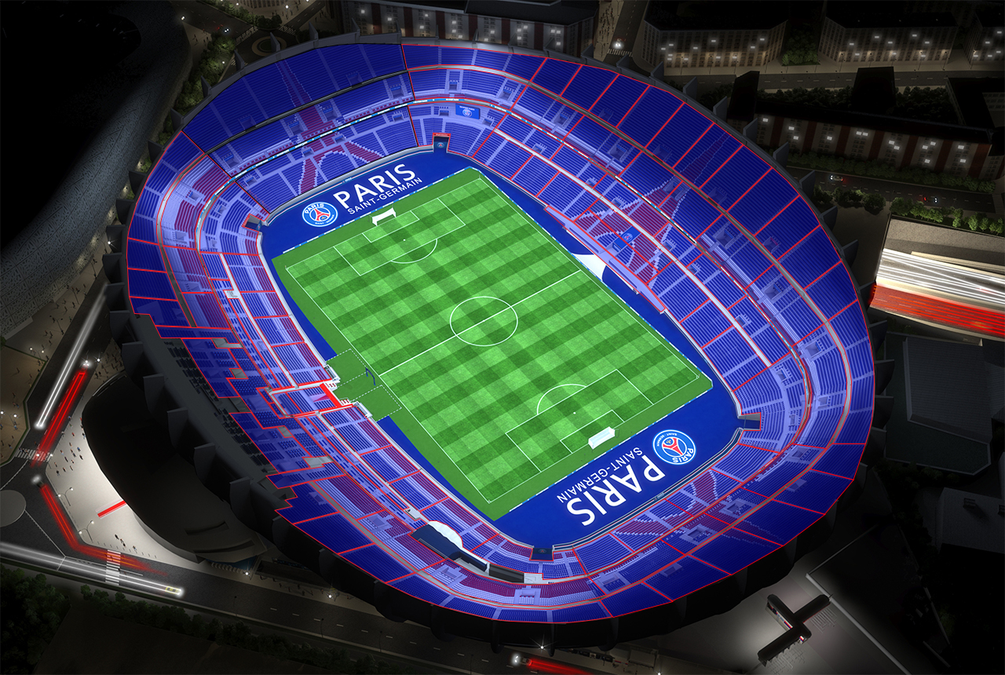

### List of features

* Show blocks (a dedicated list of blocks)
* Set one CSS code per block
* Select a block
* Click on a block
* Cancel block selection
* Show one panoramic view taken in the middle of the block
* Zoom with touch
* Pan with touch

## Block view

### Design

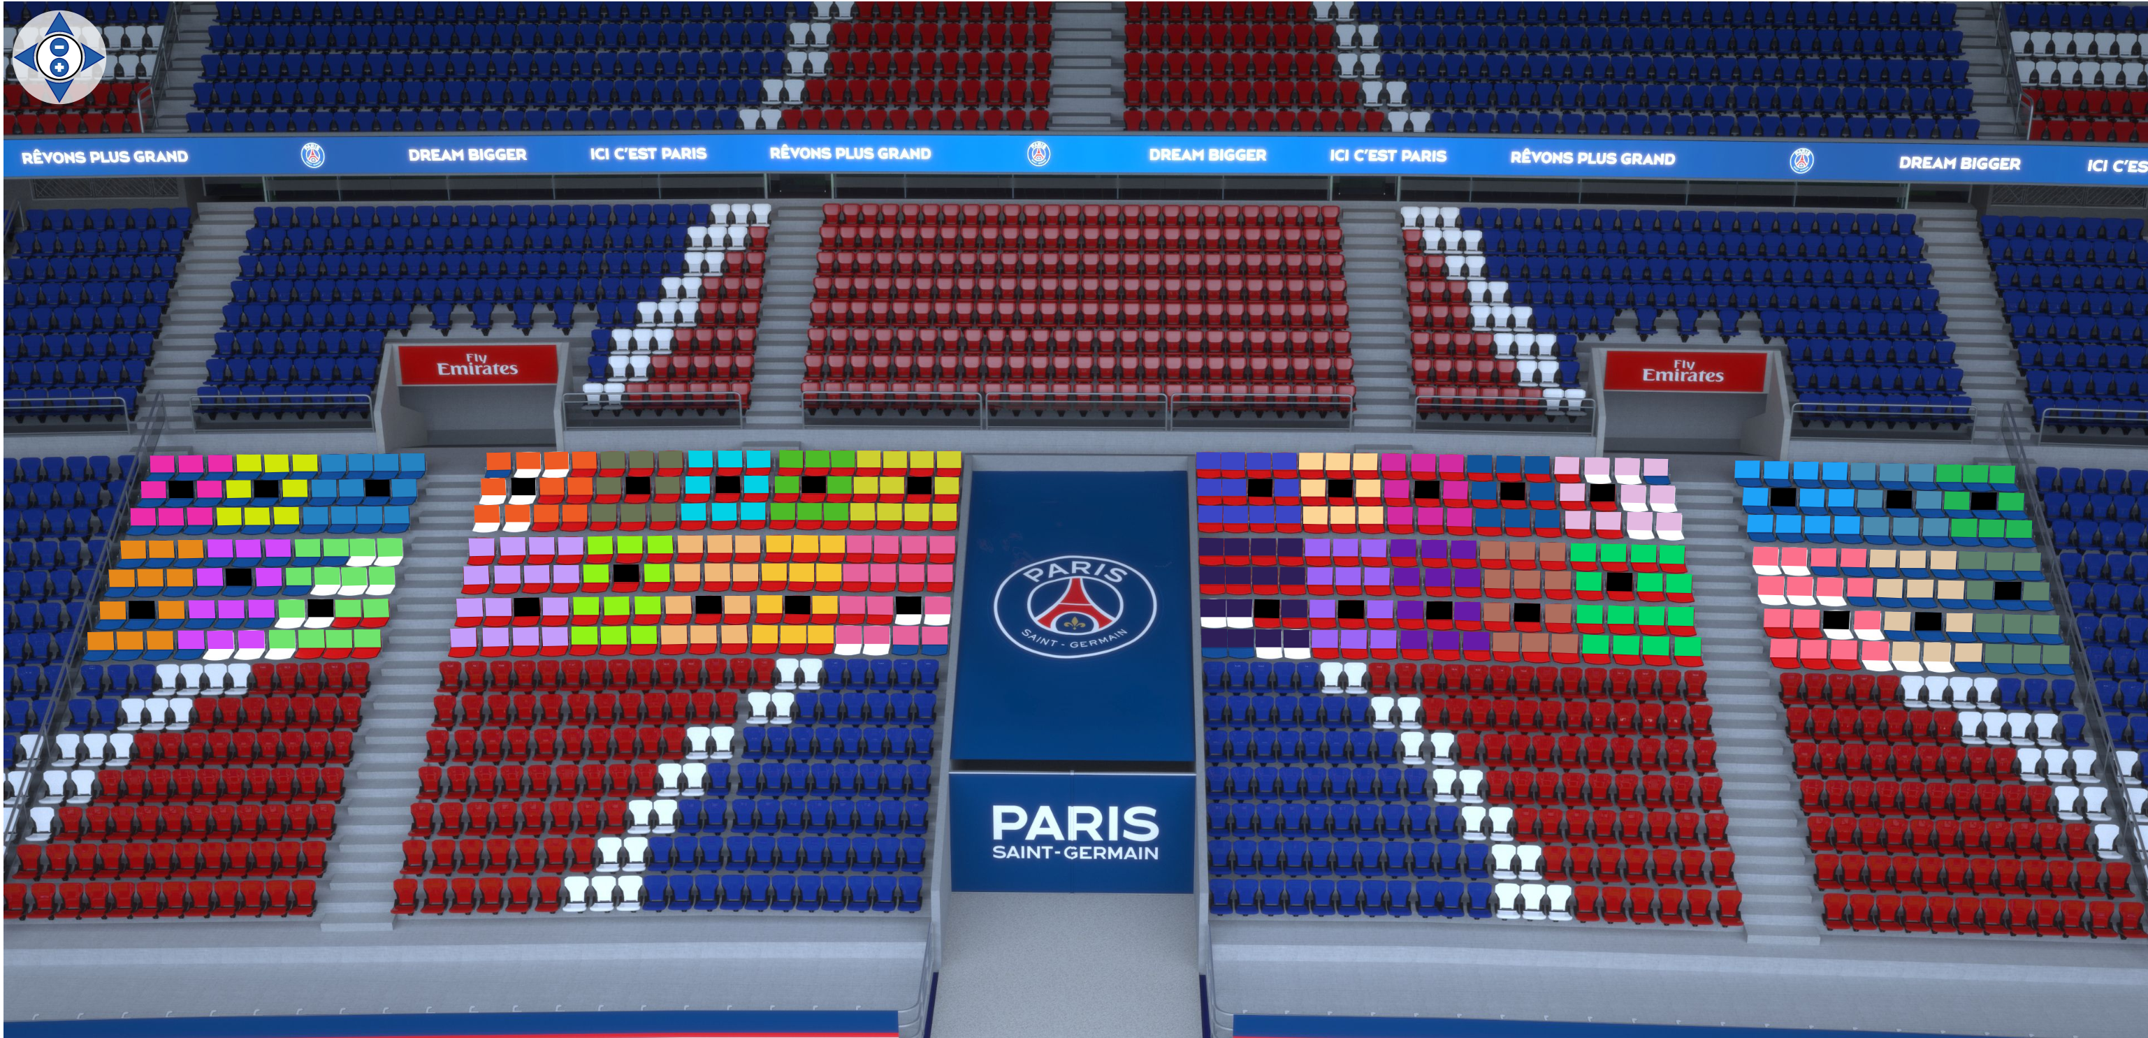

### List of features

* Show the seats
* Display a hitzone for each seat
* Set a CSS per seat
* Change the CSS on selected seats
* Display a panoramic view for each seat
* Zoom
* Pan
* Move to another block

## Panoramic view

### Design

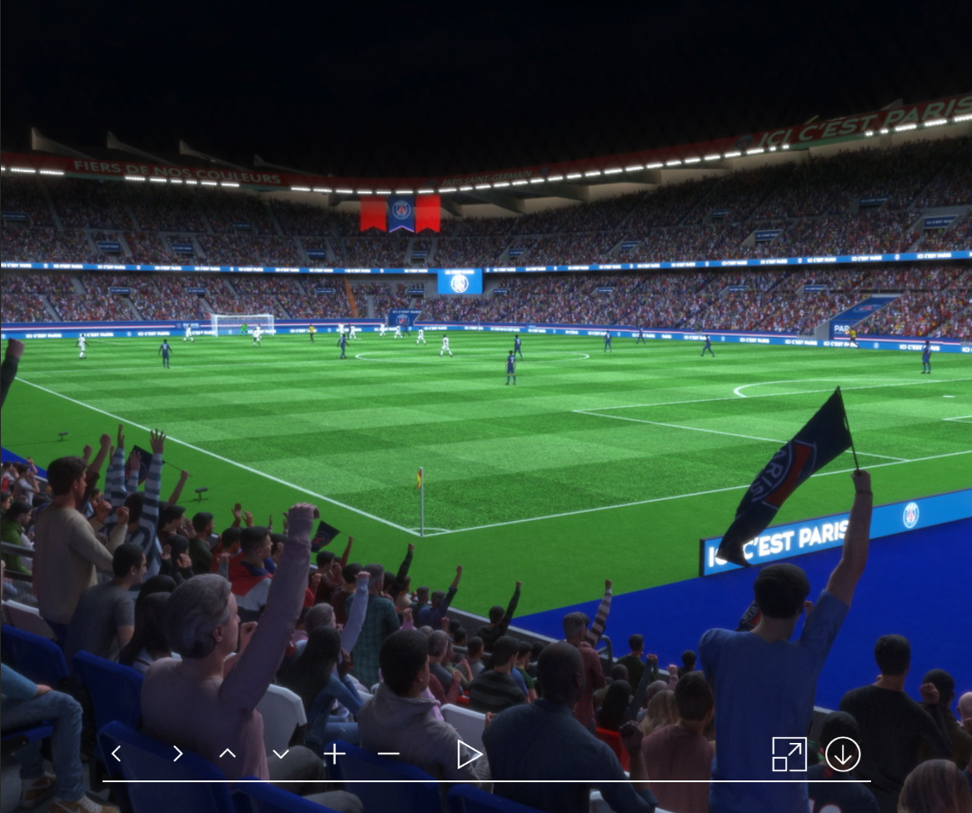

### List of features

* Zoom
* Make a rotation at 360°
* Switch to full screen (enlarge the view)
* Use the Gyroscope